**American International University-Bangladesh  
Department of Computer Science  
Faculty of Science and Technology [FST]**  
**SOFTWARE DEVELOPMENT AND PROJECT MANAGEMENT[D]**

**Section: [B]**

**Group No: 08**

**Project Title**

**Store Management System.**

**Submitted By**

|  |  |  |  |
| --- | --- | --- | --- |
| **No** | **Name** | **ID** | **Contribution** |
| **1** | **JOYDEP DHAR** | **20-44237-3** | **50%** |
| **2** | **MD. ABDUL MUNEEM ADNAN** | **20-44213-3** | **50%** |

|  |  |
| --- | --- |
|  |  |
|  |  |

**Submitted TO: MD. ANWARUL KABIR**

Submission Date: 21-12-2023

**Table of Content:**

* **Vision and Scope:**

1. **Business Requirement: 3**
   1. **Background: 3**
   2. **Business Opportunity: 3**
   3. **Business Objective: 3**
   4. **Success Metrics: 3**
   5. **Vision Statement: 3**
2. **Scope and Limitations: 4**
   1. **Major features: 4-5**
   2. **Limitations and Exclusions: 5**
3. **Business Context: 5**
   1. **Stakeholders: 5**
   2. **Project Priorities: 6**

* **Software Requirements Specifications**

1. **Introduction: 7**
   1. **Purpose: 7**
   2. **Document Conventions: 7**
2. **Overall Description****: 8**
   1. **Product Perspective: 8**
   2. **Product Functions: 9**
   3. **User Classes and Characteristics: 9-10**
   4. **Operating Environment: 10**
   5. **Design and Implementation Constraints: 11**
   6. **User Documentation: 11-12**
3. **System Requirements: 13**
   1. **Functional Requirements: 13-14**
   2. **Non-Functional Requirements: 14-16**
4. **Design and Interface Requirements: 17**
   1. **UML Diagram: 17**

**4.1.1 Use Case Diagram: 17**

**4.1.2 Class Diagram: 18**

**4.1.3 Activity Diagram: 19-22**

**4..1.4 ER Diagram: 23**

* 1. **UI/UX Design Specification: 24-28**

1. **Data Requirements: 29**
   1. **Logical Data Model: 29**
   2. **Data Dictionary: 29-30**
2. **SpiraTeam for Requirement Tools: 31-39**
3. **Conclusion: 39**

**Vision and Scope Document:**

1. **Business Requirements:**
   1. **Background:** The retail industry currently faces challenges such as manual inventory management, inefficient user roles and manual customer experience. The Store Management System aims to address these issues by providing a comprehensive solution for efficient retail operations.
   2. **Business Opportunity:** The implementation of the Store Management System presents an opportunity to transform retail operations, boost efficiency and enhance customer experience. This system aligns with the growing demand for streamlined and optimized retail environments.
   3. **Business Objectives:**

* Streamline inventory management to reduce stockouts and discrepancies.
* Implement role-based access control for efficient user roles and permissions.
* Enhance customer satisfaction through seamless transactions and product availability.
  1. **Success Metrics:**
* 80% of store employees who interact with the system for inventory and transaction management at least 3 times per week during the first quarter of implementation will continue to use the system regularly within 6 months following the initial release.
* The overall customer satisfaction rating for the store, as gathered from post-purchase surveys, should increase by at least 0.5 on a scale of 1 to 5 within 3 months after the system's launch and by 1.0 within 12 months.
  1. **Vision Statement:**

The System aims to simplify daily operations for store employees as well as customers, offering an efficient and user-friendly interface. The Store Management system enhances productivity, reduces complexities, and improves customer service compared to manual processes.

**Top of Form**

1. **Scope and Limitations:**
   1. **Major Features:**

* **Product and Inventory Management:**
  + Adding, modifying and removing products are the functionalities of Admin and Manager.
  + Inventory management with detailed product descriptions.
* **Transaction Processing:**
  + Transaction processing and billing capabilities.
  + Access to transaction reports for Admin and Manager.
  + Staff empowerment for processing customer transactions and providing receipts.
* **Additional Features:**
  + Login system for Admin, Manager, and Staff.
  + Admin's ability to add and manage Managers and Staff.
  + Resource allocation functionalities.
  + Centralized view of resources for Admin and Manager.
  + Customer details, payments and payment history management.
  + User feedback, product reviews, ratings and reports.
  + Searching for a product by name or rack ID.
  + Functionalities for returns, refunds.

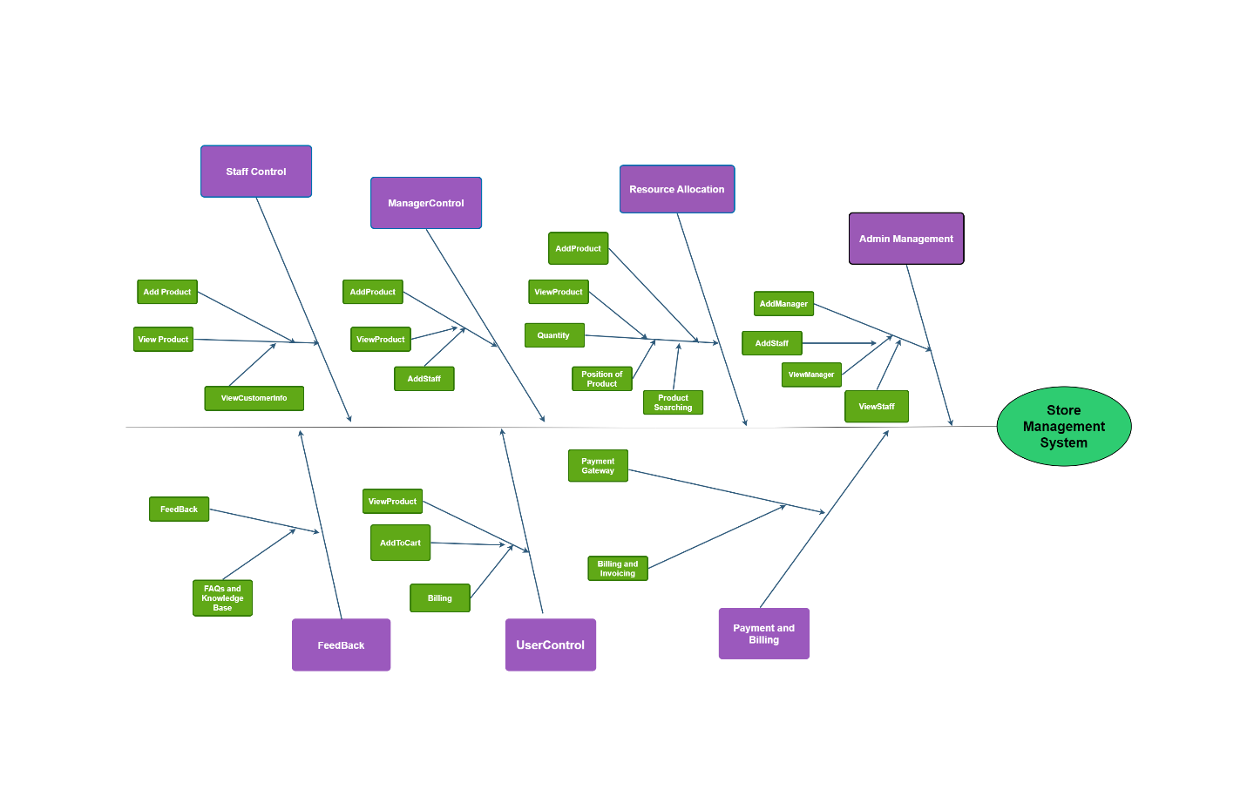

Fig 1.1: Partial Feature Tree for Store-Management-System

* 1. **Limitations and Exclusions:**
* **Time:** The project must be completed within a timeframe.
* **Budget:** Additional features are limited to those specified to stay within budget constraints.

1. **Business Context**
   1. **Stakeholders:**

* **Primary Stakeholders:**
* **Admins:** Holders of full control over the system.
* **Managers:** Responsible for product and staff management.
* **Staff:** Involved in day-to-day operations, focusing on stock and customer interactions.
* **Customers:** End-users interacting with the system during purchases.
* **Secondary Stakeholders:**
* **Developers:** Responsible for system development, coding and programming.
* **IT Support Teams:** Handling technical support and maintenance.
* **Product Suppliers:** External entities providing the store with products.
* **Business Analysts:** Analyzing system performance and providing insights.
* **Risk Management Consultants:** Advising on potential risks.
  1. **Project Priorities:**
* **User Experience (UX) and Usability:**
  + Priority is given to creating an efficient and user-friendly interface for all systems including Admin, Manager, Customer and Staff for user interaction.
* **System Functionality:**
  + Implementation of core features like product and inventory management, transaction processing and the features of Admin, Manager and Staff.
* **Security and Data Protection:**
  + Implementing strong security measures to protect user data and transaction information.
* **Performance:**
  + Performance optimization for fast response times and efficient data processing.
  + The system shall provide a responsive user interface with page load times not exceeding 3 seconds for standard operations.
  + The system must support a minimum of 100 users and 5 payment transactions at a time without any issue.

**Software Requirements Specification:**

1. **Introduction:**

The aim of this document is to provide an in-depth overview of the project's objectives and functionalities by Eagle Solution. The primary reference for all readers and project stakeholders, it promotes clear communication and a shared understanding of the project's goals. By establishing effective communication, the document facilitates a unified goal among all stakeholders, guiding the development and implementation process in a seamless and collaborative manner to achieve the expected project outcomes.

* 1. **Purpose:**

The purpose of a Store Management System is to help retail stores run more smoothly. It will improve how they manage inventory and handle transactions. The goal is to enhance efficiency, customer satisfaction and overall success.

* 1. **Document Conventions:**

This document adheres to IEEE formatting guidelines, ensuring consistency and readability.

* Font Style: **Times New Roman**
* Margin: **Normal**
* Page Size: **A4**
* Heading Size:
  + - Main Headings: **14**
    - Sub-Headings: **12**
* Text Size: **12**

1. **Overall Description:**
   1. **Product Perspective:**

The Store Management System operates as an independent system, intricately designed to enhance retail store operations. It interfaces with inventory management and sales processes, providing a user-friendly platform for admin, Customer, managers, and staff.

**Context Diagram:**

Fig 1.2: Second Layer-Context Diagram

* 1. **Product Functions:**
* **User Authentication and Login:**
* Login for Admin, Manager and Staff ensuring authorized access to system functionalities.
* **Customer Purchase:**
  + Enable customers to make purchases without login or registration, requiring only a phone number and email for record-keeping.
* **Product and Inventory Management:**
  + Allow Admin and Manager to manage products, categories, and inventory efficiently.
* **Transaction Processing:**
  + Admin and Manager have only access to provide Transactions and billing reports.
* **Additional Functions:**
  + Resource allocation, centralized views for Admin and Manager, customer details, payments, discounts, loyalty programs, user feedback and reporting.
  1. **User Classes and Characteristics:**

|  |  |
| --- | --- |
| User Class | Characteristics |
| Admin | * Manage user registrations. * Add, modify, or remove products and categories. * Access and manage inventory details. * Manage customer transactions, payments, and payment history. * Administer discounts, loyalty programs, and user blocking. * View comprehensive reports and analytics. * Control of Managers and Staff. |
| User Class | **Characteristics** |
| Manager | * Add, modify, or remove products and categories. * Access and manage inventory details. * Manage customer transactions and provide receipts. * View reports and analytics related to their assigned responsibilities. * Manage Staff. |
| Customer | * Can browse and search for products. * Can view product details, prices, and availability. * Can add products to a shopping cart. * Can proceed to checkout and place orders. * Can view order history. * May receive notifications or updates on promotions. |
| Staff | * Process customer transactions and provide receipts. * Access basic customer details. * Contribute to resource allocation functionalities. |

* 1. **Operating Environment:**
  + **Operating Systems:**
* Windows 7 to above.
  + **Software Requirements:**
* Web-based system: HTML5, CSS3, JavaScript
* Backend: .NET Core, PHP
* Database: Microsoft SQL Server
  + **Hardware Requirements:**
* Standard office computers for Admin, Manager, and Staff access (8GB RAM, Core i5 processor)
* Point of Sale (POS) terminals for Customer interactions
* Centralized server for data storage and processing (16GB RAM, Quad-Core processor, SSD storage)
  1. **Design and Implementation Constraints:**
  + **Time Constraint:**
  + The project must be completed within a predefined timeframe. This constraint ensures that the development process adheres to a specific schedule, meeting milestones and deadlines in a timely manner.
  + **Budget Constraint:**
    - The implementation of all features is limited to those specified to stay within budget constraints. Any proposed enhancements or modifications must align with the allocated budget to maintain financial feasibility.
  1. **User Documentation:**

User documentation is a critical component of the Store Management System, aiming to provide comprehensive guidance to users for effective system utilization. The documentation encompasses various aspects of the system, ensuring clarity and ease of use.

* + **Login:**
* Clear instructions on how to log in to the system based on user roles. Different login processes for Admin, Manager, and Staff with functionalities.
  + **Dashboard:**
* All Key features, metrics and functionalities detailed are into the dashboard.
  + **Product and Inventory Management:**
* Admin and Manager roles on adding, modifying, removing products and including assigning products to categories and managing inventory.
  + **Transaction Processing:**
  + Admin and Manager have only access to provide Transactions and billing reports.
  + Instructions on how Staff can process customer transactions and provide receipts.
  + **User Roles and Permissions:**
  + Clear delineation of roles and permissions for Admin, Manager, and Staff and their responsibilities.
  + **Resource Allocation:**
  + How Admin and Manager can allocate resources, providing a centralized view of resources and managing them efficiently instruction will be given.
  + **Customer Details and Payments:**
  + Documentation on capturing and managing customer details, processing payments and payment history.
  + **Security Measures:**
  + Information on the secure login system, user authentication and measures taken to ensure data confidentiality.
  + **Additional Features:**
  + Proper Instruction on implementing and using additional features such as blocking users, applying discounts, loyalty programs, handling returns and utilizing reporting functionalities.
  + **Feedback and Reviews:**
  + Procedures for managing user feedback, product reviews and ratings within the system.
  + **Search Functionality:**
  + Instructions on using the search system for customer navigation, ensuring an efficient and user-friendly.
  + **Returns and Refunds:**
  + Guidelines for handling returns, procedure and terms of refunds and utilizing the reporting system for tracking such transactions.

1. **System Requirements**
   1. **Functional Requirements (System Features):**
      1. **Customer Purchase**

* Customers can initiate a purchase without the need for login or registration.
* The customer provides their phone number and email to complete the purchase.
* The system captures the customer's purchase details and associates them with their phone number for record-keeping.

*Priority Level:* High

*Precondition:* Customer provides a valid phone number and email.

*Cross-references:* 3.2, 3.3

* + 1. **User Authentication and Login**

**Admin:**

* + - * Full access to all system functionalities.

**Manager:**

* + - * Adds and manages staff.
      * Controls and views customer details.
      * Resource allocation functionalities.

**Staff:**

* + - * Limited access to resource allocation functionalities.

*Priority Level:* High

*Precondition:* Users provide valid login ID and Password.

*Cross-references:* 3.1.1, 3.3

* + 1. **Product and Inventory Management**
* Allow Admin and Manager to add, modify, and remove products with detailed descriptions.
* Assign products to specific categories and manage inventory.

*Priority Level:* High

*Precondition:* Admin or Manager role

*Cross-references:* N/A

* + 1. **Transaction Processing**
* Facilitate seamless transactions and billing.
* Grant Admin and Manager access to transaction reports and analytics.
* Empower Staff to process customer transactions and provide receipts.

*Priority Level:* High

*Precondition:* Admin, Manager, or Staff role

*Cross-references:* N/A

* + 1. **Additional Features**
* Implement a secure login system for Admin, Manager, and Staff.
* Enable Admin to add and manage Managers and Staff.
* Implement resource allocation functionalities.
* Provide a centralized view of resources for Admin and Manager.
* Incorporate features for customer details, payments, and payment history.
* Integrate functionalities for blocking users, applying discounts, and loyalty programs.
* Implement systems for user feedback, product reviews, and ratings.
* Develop a robust search system for customer navigation.
* Implement functionalities for returns, refunds, and comprehensive reporting.

*Priority Level:* High

*Precondition:* Admin, Manager, or Staff role

*Cross-references:* N/A

* 1. **Non-Functional/Quality Requirements:**
     1. **Performance**
* The software must have fast response times for user requests.

*Priority Level:* High

*Precondition:* None

*Cross-references:* N/A

* + 1. **Usability**
* The software must provide clear and concise error messages to assist users in resolving issues.
* The software must be intuitive and responsive to user input.

*Priority Level:* Medium

*Precondition:* None

*Cross-references:* N/A

* + 1. **Security**
* The software must use strong encryption and hashing algorithms to protect user data.
* The software must have user authentication and access control measures to prevent unauthorized access.
* The software must comply with industry-specific security standards and regulations.

*Priority Level:* High

*Precondition:* None

*Cross-references:* N/A

* + 1. **Interoperability**
* The software must be able to integrate with other systems and applications used by the organization.

*Priority Level:* Low

*Precondition:* None

*Cross-references:* N/A

* + 1. **Availability**
* The software must have a high level of availability to ensure that users can access the system at all times.
* The software must be able to handle unexpected spikes in traffic without impacting the availability of the system..
* The software must have a backup system in place to ensure that data can be recovered in the event of a hardware failure or other system outage.

*Priority Level:* High

*Precondition:* None

*Cross-references:* N/A

* + 1. **Maintainability**
* The software must have clear documentation and code comments to aid in maintenance and troubleshooting.
* The software must adhere to coding standards and best practices to ensure maintainability.
* The software must have a testing environment for updates and patches before deploying to production.

*Priority Level:* Medium

*Precondition:* None

*Cross-references:* N/A

* + 1. **Reliability**
* The software must be able to recover from system failures without data loss.
* The software must have a failover plan in case of unexpected system downtime.

*Priority Level:* Medium

*Precondition:* None

*Cross-references:* N/A

1. **Design and Interface Requirements:**
   1. **UML Diagram:**
      1. **Use Case Diagram:**

**Fig 1.3: Use-case Diagram of Store-Management-System**

* + 1. **Class Diagram:**

A class diagram in the UML is a type of static structure diagram that describes the structure of a system by showing the systems classes, their attributes, operations (function and methods) and the relationship among objects.

Classes included in following diagram:

* + - * Admin
      * Manager
      * Staff
      * Customer
      * Carts
      * Payment

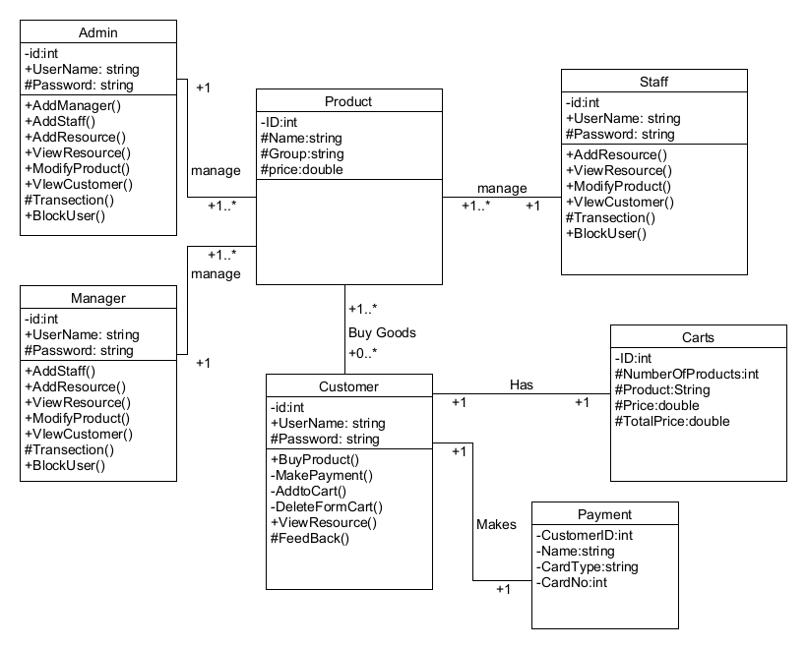

**Fig 1.4: Class Diagram of Store-Management-System**

* + 1. **Activity Diagram:**

Activity Diagrams are representations of workflows of stepwise activities and actions with support for choice, iteration and concurrency. The process of activity diagram is same as state diagram. In this diagram, we have four main actors:

* + - * Admin
      * Manager
      * Staff
      * Customer

**Fig 1.5.1: Admin Activity Diagram for Store-Management-System**

**Fig 1.5.2: Manager Activity Diagram for Store-Management-System**

**Fig 1.5.3: Staff Activity Diagram of Store-Management-System**

**Fig 1.5.4: Customer Activity Diagram of Store-Management-System**

* + 1. **ER Diagram:**

**Fig 1.5: ER Diagram of Store-Management-System**

* 1. **UI/UX Design Specification:**

**Fig 1.6.1: Login UI**

**Fig 1.6.2: Admin Dashboard**

**Fig 1.6.3: Add in Inventory**

**Fig 1.6.4: Add Manager and Staff with Role Assign**

**Fig 1.6.5: Staff Profile Add**

**Fig 1.6.6 Customer Dashboard and View Inventory**

**Fig 1.6.6: Cart Products**

**Fig 1.6.7: Payment Options**

**Fig 1.6.8: Receipts Print Options**

1. **Data Requirements:**
   1. **Logical Data Model:**

**Fig 1.7: logical Data Model**

* 1. **Data Dictionary:**

|  |  |  |  |  |
| --- | --- | --- | --- | --- |
| **Entity** | **Attribute** | **Type/Size** | **Validation** | **Key** |
|  | A_id | int (5) | Required | Primary |
| **Admin** | A_Name | String (50) | Required |  |
|  | role | String (10) | Required |  |
|  | A_password | String (20) | Required |  |
|  | M_id | int (5) | Required | Primary |
| **Manager** | M_name | String (50) | Required |  |
|  | role | String (10) | Required |  |
|  | M_password | String (20) | Required |  |
|  | S_id | int (5) | Required | Primary |
| **Staff** | S_Name | String (50) | Required |  |
|  | role | String (10) | Required |  |
|  | S_password | String (20) | Required |  |
|  | C_id | int (5) | Required | Primary |
|  | C_name | String (50) | Required |  |
| **Customer** | email | String (50) | Required |  |
|  | phone | String (50) | Required |  |
|  | P_id | int (5) | Required | Primary |
|  | P_name | String (50) | Required |  |
| **Product** | description | String(50) | Optional |  |
|  | Category_id | int (5) | Required | Foreign |
|  | price | Decimal | Required |  |
|  | quantity_in_stock | int (20) | Required |  |
| **Rack** | R_id | int (5) | Required | Primary |
|  | Location | String (20) | Required |  |
|  | Capacity | int (5) | Required |  |
|  | Category_id | int (5) | Required | Foreign |
| **Category** | Cat_id | int (5) | Required |  |
|  | Cat_name | int (5) | Required |  |
|  | T_id | int (5) | Required | Primary |
| **Transaction** | time | Datetime | Required |  |
|  | total_amount | Decimal (50) | Required |  |
|  | customer_id | int (5) | Required | Foreign |
|  | Res_id | int (5) | Required | Primary |
| **Resource** | name | String (20) | Required |  |
|  | availability | Boolean | Required |  |
|  | F_id | int (5) | Required | Primary |
| **Feedback** | user_id | int (5) | Required | Foreign |
|  | feedback_text | String (20) | Optional |  |
|  | rating | int (5) | Required |  |
|  | Ret_id | int (5) | Required | Primary |
| **Return** | transaction_id | int (5) | Required | Foreign |
|  | reason | String (20) | Optional |  |
|  | status | String (20) | Optional |  |

1. **SpiraTeam for Requirement Tools:**

**Fig 1.8.1: Requirement for Release -1**

**Fig 1.8.2: Requirement for Release-2**

**Fig 1.8.3: Requirement for Release-3**

**Fig 1.8.4: Sprint Completion**

**Fig 1.8.5: Requirement Completion**

**Fig 1.8.6: All Requirement Summary**

**  
Fig 1.8.7: Requirement Graph**

**Fig 1.8.8: Schedule**

**Fig 1.8.9: Task Burndown**

**Fig 1.8.10: Task Velocity**

**Fig 1.8.11: Requirement Graph**

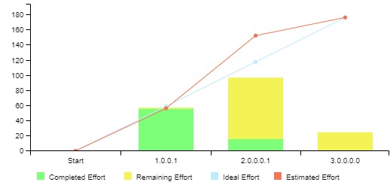

**Fig 1.8.12: Work-rate Graph**

|  |  |
| --- | --- |
|   **Fig:1.9.1: Requirement Collection** |   **Fig:1.9.2: Requirement Collection** |
|   **Fig:1.9.3: Requirement Collection** |   **Fig:1.9.4: Requirement Collection** |
|   **Fig:1.9.5: Requirement Collection** | **Fig:1.9.6: Requirement Collection** |
| **Fig:1.9.7: Requirement Collection** | **Fig:1.9.8: Requirement Collection** |
| **Fig:1.9.9: Requirement Collection** | **Fig:1.9.10: Requirement Collection** |
| **Fig:1.9.11: Requirement Collection** | **Fig:1.9.12: Requirement Collection** |
| **Fig:1.9.13: Requirement Collection** | **Fig:1.9.14: Requirement Collection** |
| **Fig:1.9.15: Requirement Collection** | **Fig:1.9.16: Requirement Collection** |

|  |
| --- |
| **Fig:1.9.17: Requirement Collection** |

1. **Conclusion:**

The Store Management System offers a user-friendly platform for retail stores. It simplifies inventory management, secures user interactions and transactions with features like categorizing products, managing resources and generating reports. The system prioritizes customer engagement through secure logins, loyalty programs and user feedback. Its scalable and efficient design is tailored to meet the diverse needs of retail establishments, ultimately optimizing store operations and enhancing the overall customer experience.